Compilation Instructions:
- Download the Parser.zip file and extract it

- Go to the ‘bin’ folder and double-click the “path.bat” file which will open up command prompt with the path where the source code resides
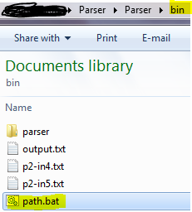

- Type “java parser/Parser [input filename].txt output.txt” [without the quotes and [input filename] represents the actual filename]. See below examples:

- Output.txt file will be saved under the same ‘bin’ folder.

- Repeat step 3 to test with other input file

